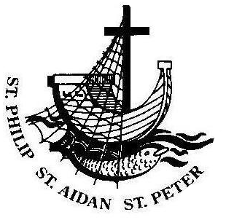
ANGLICAN PARISH OF BOX HILL
Sixth Sunday after Pentecost
12 July, 2020

Parish Link

Our Vicar writes…
Today’s Gospel passage from Matthew is the well-known parable of the Sower. Many may reflect upon what type of “soil” they are and whether they are receptive or not to the Word of God. But what if this parable is not about our own successes and failures and birds and rocks and thorns but about the extravagance of a sower who flings seed everywhere, wastes it with holy abandon; confident that there is enough seed to go around, that there is plenty, and that when the harvest comes in at last it will fill every barn in the neighbourhood to the rafters. The focus is not on us and our shortfalls but on the generosity of our maker. When Christians today proclaim the counter-cultural gospel of love, peace, justice, and acceptance of all God's children, we face many of the same responses our ancestors in faith encountered: persecution, indifference, hostility, closed minds, loss of place and community. And yet God works great wonders in all situations, and is astonishingly extravagant in offering grace and new life in the harshest of situations and the deepest deprivations. The sower is remarkably free in throwing the seed on all sorts of potential "growth areas." There's no calculation or careful husbandry of the seeds in the pocket. In the face of all sorts of obstacles and dangers, the sower counts on the bountiful return of a few seeds; they imagine the plentiful harvest reaped when even a few of the seeds find fertile soil. May we today remember that our God is a generous God.

Mission Statement
Sharing the Good News
Telling the story afresh
Expressing God’s love
Nurturing and sharing faith
Equipping to serve
Serving the community
Vision
To ensure that there continues to be a living, committed, communal Anglican presence of liturgical celebration, nurture and outreach in Box Hill.

FOR YOUR INFORMATION
FIRST AID KIT – Located in the office and kitchen.
TOILETS – Located in the Church Hall and in the church building through the church doors front right.
WHEELCHAIR – Located in the toilet for the disabled upstairs.
FIRE & EMERGENCY – Please make yourself aware of the nearest escape route in the event of an emergency or fire.
OH&S – Please ensure that any incidents/accidents are reported to the Vicar or Wardens and incident report completed.

Sentence
The words you have spoken are spirit and life, O Lord; you have the words of eternal life. John 6.63, 68
Prayer of the Day
Bountiful God, we thank you for planting in us the seed of your word: by your Holy Spirit, help us to receive it with joy, and to live according to it, that we may grow in faith and hope and love; through Jesus Christ our Lord, who lives and reigns with you in the unity of the Holy Spirit, one God, for ever and ever. Amen.
Readings
First Reading: Genesis 25.19-34
¹⁹ These are the descendants of Isaac, Abraham’s son: Abraham was the father of Isaac, ²⁰ and Isaac was forty years old when he married Rebekah, daughter of Bethuel the Aramean of Paddan-aram, sister of Laban the Aramean. ²¹ Isaac prayed to the Lord for his wife, because she was barren; and the Lord granted his prayer, and his wife Rebekah conceived. ²² The children struggled together within her; and she said, ‘If it is to be this way, why do I live?’ So she went to inquire of the Lord. ²³ And the Lord said to her, ‘Two nations are in your womb, and two peoples born of you shall be divided; one shall be stronger than the other, the elder shall serve the younger.’ ²⁴ When her time to give birth was at hand, there were twins in her womb. ²⁵ The first came out red, all his body like a hairy mantle; so they named him Esau. ²⁶ Afterwards his brother came out, with his hand gripping Esau’s heel; so he was named Jacob. Isaac was sixty years old when she bore them. ²⁷ When the boys grew up, Esau was a skilful hunter, a man of the field, while Jacob was a quiet man, living in tents. ²⁸ Isaac loved Esau, because he was fond of game; but Rebekah loved Jacob. ²⁹ Once when Jacob was cooking a stew, Esau came in from the field, and he was famished. ³⁰ Esau said to Jacob, ‘Let me eat some of that red stuff, for I am famished!’ (Therefore he was called Edom.) ³¹ Jacob said, ‘First sell me your birthright.’ ³² Esau said, ‘I am about to die; of what use is a birthright to me?’ ³³ Jacob said, ‘Swear to me first.’ So he swore to him, and sold his birthright to Jacob. ³⁴ Then Jacob gave Esau bread and lentil stew, and he ate and drank, and rose and went his way. Thus Esau despised his birthright.
For the word of the Lord, thanks be to God

Psalm: 119.105-112

¹⁰⁵ Your word is a lantern to my feet:
and a light to my path.
¹⁰⁶ I have vowed and sworn an oath:
to keep your righteous judgements.
¹⁰⁷ I have been afflicted beyond measure:
Lord, give me life according to your word.
¹⁰⁸ Accept, O Lord, the freewill offerings of my mouth:
and teach me your judgements.
¹⁰⁹ I take my life in my hands continually:
yet I do not forget your law.
¹¹⁰ The wicked have laid a snare for me:
but I have not strayed from your precepts.
¹¹¹ Your commands are my inheritance for ever:
they are the joy of my heart.
¹¹² I have set my heart to fulfil your statutes:
always, even to the end.

Second Reading: Romans 8.1-11
¹ There is therefore now no condemnation for those who are in Christ Jesus. ² For the law of the Spirit of life in Christ Jesus has set you free from the law of sin and of death. ³ For God has done what the law, weakened by the flesh, could not do: by sending his own Son in the likeness of sinful flesh, and to deal with sin, he condemned sin in the flesh, ⁴ so that the just requirement of the law might be fulfilled in us, who walk not according to the flesh but according to the Spirit. ⁵ For those who live according to the flesh set their minds on the things of the flesh, but those who live according to the Spirit set their minds on the things of the Spirit. ⁶ To set the mind on the flesh is death, but to set the mind on the Spirit is life and peace. ⁷ For this reason the mind that is set on the flesh is hostile to God; it does not submit to God’s law—indeed it cannot, ⁸ and those who are in the flesh cannot please God. ⁹ But you are not in the flesh; you are in the Spirit, since the Spirit of God dwells in you. Anyone who does not have the Spirit of Christ does not belong to him. ¹⁰ But if Christ is in you, though the body is dead because of sin, the Spirit is life because of righteousness. ¹¹ If the Spirit of him who raised Jesus from the dead dwells in you, he who raised Christ from the dead will give life to your mortal bodies also through his Spirit that dwells in you.
For the word of the Lord, thanks be to God

The Gospel of our Lord Jesus Christ
according to Matthew, Chapter 13, beginning at verse 1.
¹ That same day Jesus went out of the house and sat beside the lake. ² Such great crowds gathered around him that he got into a boat and sat there, while the whole crowd stood on the beach. ³ And he told them many things in parables, saying: ‘Listen! A sower went out to sow. ⁴ And as he sowed, some seeds fell on the path, and the birds came and ate them up. ⁵ Other seeds fell on rocky ground, where they did not have much soil, and they sprang up quickly, since they had no depth of soil. ⁶ But when the sun rose, they were scorched; and since they had no root, they withered away. ⁷ Other seeds fell among thorns, and the thorns grew up and choked them. ⁸ Other seeds fell on good soil and brought forth grain, some a hundredfold, some sixty, some thirty. ⁹ Let anyone with ears listen!’ ¹⁸ ‘Hear then the parable of the sower. ¹⁹When anyone hears the word of the kingdom and does not understand it, the evil one comes and snatches away what is sown in the heart; this is what was sown on the path. ²⁰ As for what was sown on rocky ground, this is the one who hears the word and immediately receives it with joy; ²¹ yet such a person has no root, but endures only for a while, and when trouble or persecution arises on account of the word, that person immediately falls away. ²²As for what was sown among thorns, this is the one who hears the word, but the cares of the world and the lure of wealth choke the word, and it yields nothing. ²³But as for what was sown on good soil, this is the one who hears the word and understands it, who indeed bears fruit and yields, in one case a hundredfold, in another sixty, and in another thirty.’
Glory to you Lord Jesus Christ
For the Gospel of our Lord, praise to you Lord Jesus Christ
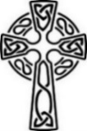
Years Mind
Peter Terbeck, Alvin Kruger, Joan Holmes, Betty Groom, Florence Matthews
whose anniversaries occur at this time.
Prayer Points
The Church: Pray for the Anglican Church of Papua New Guinea (Abp Allan Migi); Mission Agencies of the Anglican Church of Australia; Hospital Chaplaincy (Stephen Delbridge, Co-ordinator and Chaplains); St Dunstan’s Camberwell (Roberta Hamilton); St Matthew’s Cheltenham – pastoral visit (Bp Paul Barker); St James’ East St Kilda – pastoral visit (Bp Genieve Blackwell); St Mary’s Melbourne North – pastoral visit (Bp Genieve Blackwell).
The Parish: Give thanks for those working in the parish to keep it active and safe, including Men at Work, those providing flowers, wardens and Parish Council as well as our clergy.
The World: Pray for the victims of floods and landslides in Japan.
The Nation: Pray for our doctors, nurses and ambulance paramedics.
Names of those in our parish who need our prayer:
Eric and Bev, Phil and Sandra, Joan, Alistair, Freya, John, Lauren, Mark, Sue, Christine, Lorraine, Neville, June, Gayle, Nigel, Eliza, Nancy, Kate, Gwen, Russ, Betty, Jessie, Don, Jim, Alma, Muriel, Faye, Eileen, Nola, Margaret.
Prayer of the Week
O Lord, we beseech you mercifully to receive the prayers of your people who call upon you, and grant that they may both perceive and know what things they ought to do, and also may have grace and power faithfully to fulfil them; through Jesus Christ our Lord. Amen.

Prayer in time of an epidemic
Lord Jesus Christ, healer and friend, come and care for all of us through the danger and uncertainty of the coronavirus epidemic. To people who are sick, bring healing. To people who are displaced, isolated, or cut off from family, friends or work, bring comfort and companionship. Work with medical staff as they care for the sick, and protect them from harm. Give skill and fruitful research to scientists as they search for treatments, prevention and a cure. To public health authorities, give wisdom to decide the best ways to manage both this crisis and our anxieties. When communities are fearful, give a calm spirit, and kindness to neighbours and strangers. Through this testing time, and through all the risks we face together, teach us once again how we can love one another as you have loved us. Amen

Daily Readings
Monday | Isaiah 1.10-17 | Ps 50.7-11 | Matthew 10.34-11.1
Tuesday | Isaiah 7.1-9 | Ps 48.1-8 | Matthew 11.20-24
Wednesday | Isaiah 10.5-7, 13-16 | Ps 94.8-15 | Matthew 11.25-27
Thursday | Isaiah 26.7-9, 12, 16-19 | Ps 102.18-22 | Matthew 11.28-30
Friday | Isaiah 38.1-8, 21-22 | Ps 32.1-6 | Matthew 12.1-8
Saturday | Micah 2.1-5 | Ps 10.13-16 | Matthew 12.14-21

ABM Pew Reflections
Today we read of hungry Esau throwing away his birthright for a mess of potage, a lentil stew, cooked by his brother, Jacob. It was an expensive deal: The son who had the birthright became the family leader on his father’s death and inherited twice as much as any other brother (Deuteronomy 21.15-17). What valuable things have we thrown away for short-term gain in our lives? Pray that we can see the true value of the people and relationships we have in each facet of our lives, and that we can give thanks to God for everything that is precious. Give thanks for the Iglesia Filipina Independiente, the Philippine Independent Church.

If you have anything you would like included in
the Parish Link Notices, please let Cecilia know in writing before Thursdays or email anglicans.boxhill@bigpond.com

CHURCH CLOSED
With the new coronavirus restrictions, there will be no attendance at services at St Peter’s until further notice. The Sunday morning service will be streamed on YouTube as usual at 9.30am each Sunday morning.

SENIORS ONLINE
Whitehorse City Council is providing some “Stay Connected” activities and one of those is a link to a range of games including crossword, code cracking, etc. If you would like to access it, the address is: https://www.seniorsonline.vic.gov.au/services-information/games/crossword
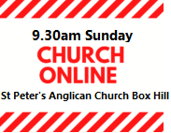

Service this Sunday 12 July (Control and click)
OR go to https://www.youtube.com/watch?v=1DJb-u2zXzM&feature=youtu.be

Good News
In the May Good News several people contributed news about how things were going for themselves and for the parish. It was still early days with autumn weather and people were cheerful and upbeat.
Where are we now? It would be good to have some more news of how people are going and what is happening now that things have got harder and we are asking How Long?
All contributions for August Good News welcome.
Send to Harry, ahmkerr@hotmail.com by July 27th

DONATIONS OF ESSENTIAL ITEMS
Basic grocery items can still be donated on a Saturday morning to the Undercroft (or left in the office during the week). Thanks to Father Alasdair who is co-ordinating this effort.
Drop off time:10.00-11.00am
Items required: rice, pasta, pasta sauce, full-cream milk, flour, breakfast
cereal.

BREAD DELIVERY
St Peter’s is still receiving deliveries of bread, and as usual, some weeks there is more bread than others. If you would like to pick some up, ring Alasdair (0438 323 059) on Saturday mornings to find out if any is available and then come over to St Peter’s to get the bread. Social distancing rules, of course, will apply.
Left over bread will be kept in the Office or Undercroft for collection until Thursdays.

PUZZLING…
Answer to last week’s puzzle: (Apologies, there are only 29!)
This is a most remarkable puzzle. It was found by a gentleman in an airplane seat pocket, on a flight from Los Angeles to Honolulu, keeping him occupied for hours. He enjoyed it so much that he passed it on to some friends. One friend from Illinois worked on this while fishing from his john boat. Another friend studied it while playing his banjo. Elaine Taylor, a columnist friend, was so intrigued by it she mentioned it in her weekly newspaper column. Another friend judges the job of solving this puzzle so involving, she brews a cup of tea to help her nerves. There will be some names that are really easy to spot. That's a fact. Some people, however, will soon find themselves in a jam, especially since the book names are not necessarily capitalized. Truthfully, from answers we get, we are forced to admit it usually takes a minister or a scholar to see some of them at the worst. Research has shown that something in our genes is responsible for the difficulty we have in seeing the books in this paragraph. During a recent fundraising event, which featured this puzzle, the Alpha Delta Phi lemonade booth set a new record. The local paper, The Chronicle, surveyed over 200 patrons who reported that this puzzle was one of the most difficult that they had ever seen. As Daniel Humana humbly puts it, "The books are all right here in plain view hidden from sight." Those able to find all of them will hear great lamentations from those who have to be shown. One revelation that may help is that books like Timothy and Samuel may occur without their numbers. Also, keep in mind, that punctuation and spaces in the middle are normal. A chipper attitude will help you compete really well against those who claim to know the answers. Remember, there is no need for a mad exodus; there really are 30 books of the Bible lurking somewhere in this paragraph waiting to be found. God Bless.

New Puzzle
To solve Bible Verse Boxes, drop the letters from each vertical column - not necessarily in the order in which they appear - into the empty squares below them to spell a familiar Bible verse reading from left to right, line by line. Words may continue from one line to the next; black squares indicate ends of words. The book from which each verse is taken is shown above its grid. Punctuation has been omitted.
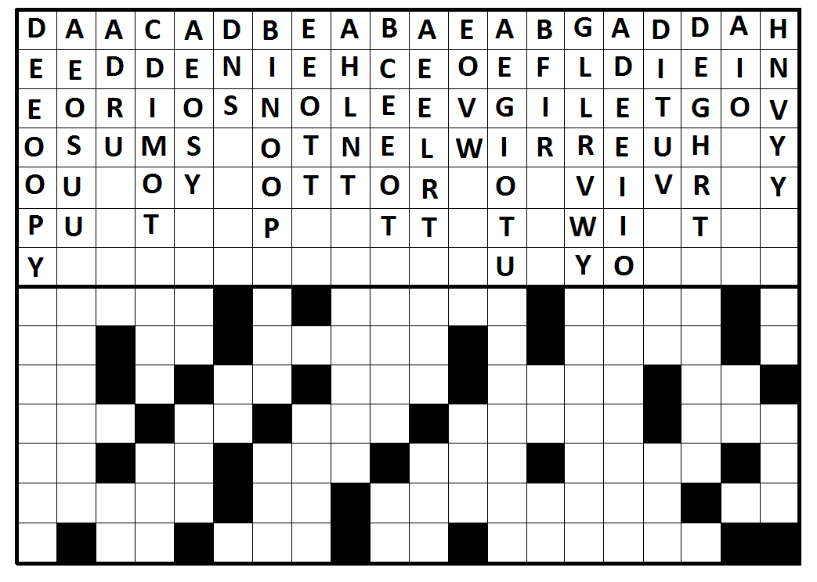
to make you smile…
Divine Definitions

Aspire Pointy bit on a church Curate A doctor
Damnation Holland Vespa Evensong on a scooter
Hebrew Jewish teabag
Jihad The cry of the fundamentalist cowboy
Beatitude Stroppy mood common in teenage insects

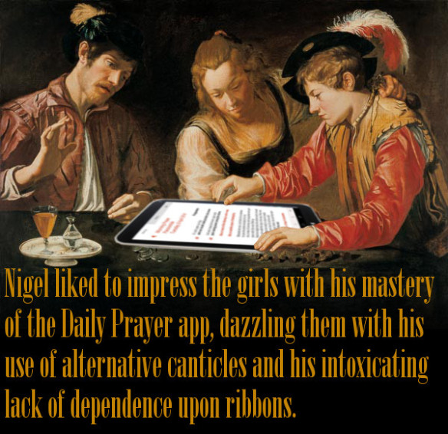
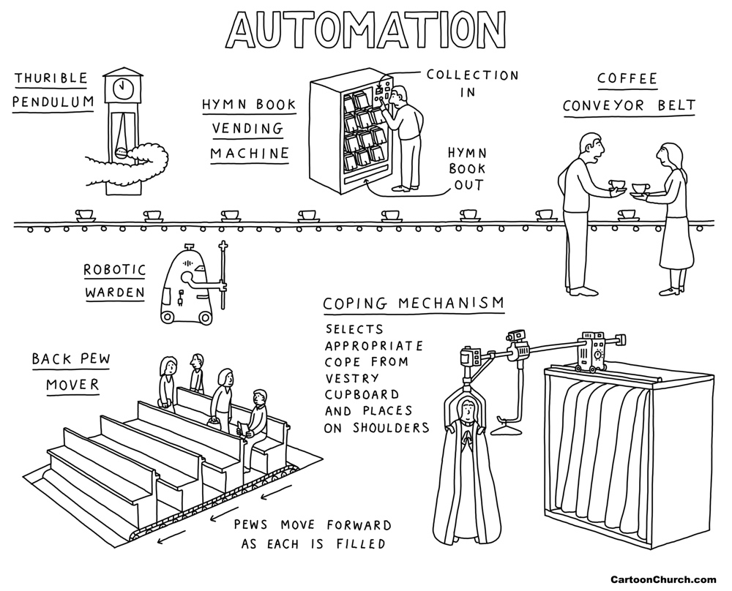

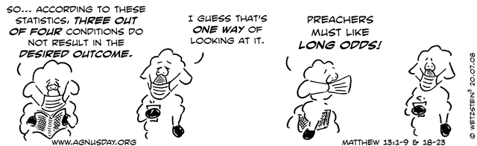

This Week
Vicar
The Reverend Shane Hübner
T 0432 681 177
E vicar@anglicansboxhill.org.au
Honorary Clergy
The Rt Rev George Hearn,
T 9840 7816
Reverends:
Betty Bracken 9939 5881
John Stockdale 0418 536 284
Harry Kerr 9893 4946
Alasdair MacKinnon-Love 0438 323 059
E alasdair@mackinnonlove.com
Sudanese Ministry
Reverend Joseph Arou
T 0431 541 535
E lokagai@hotmail.com
Chinese Ministry
The Reverend Esther Zhang
T 0405 602 439
Family Minister
Barbara Plumridge
T 0405 193 122
E barbara.plumridge@gmail.com

SUN 12.7.20
Sixth Sunday after Pentecost
9.30am Streamed live service
(Go to our website for services and
reflections.)
MON 13.7.20

TUES 14.7.20
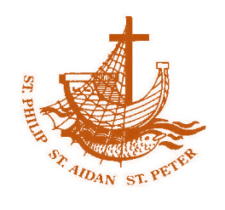
8.30am-12.30pm Office open
WED 15.7.20

THU 16.7.20
10.00-2.00pm Office open

FRI 17.7.20

SAT 18.7.20
Food drop off and bread delivery

SUN 19.7.20
Seventh Sunday after Pentecost
9.30am Streamed live service

ST PETER’S
1038 Whitehorse Rd, Box Hill.
Parish Office: 9899 5122

Email
anglicans.boxhill@bigpond.com
Website www.anglicansboxhill.org.au

Office Hours:
Tues 8.30am – 12.30pm
Thu 10.00am – 2.00pm

Wardens:
Margaret Dooley 0438 129 161
Sophia Errey 9878 6297
Garry Plumridge 9898 5193
Baptism, marriage & funeral by arrangement. Clergy are available for confession / counselling by appointment.

Prayers and Readings from A Prayer Book for Australia, Copyright Broughton Publishing 1995.
The Scripture quotations contained herein are from the New Revised Standard Version of the Bible © 1989 the Division of Christian Education of the National Council of the Churches of Christ in the United States of America, and are used by permission. All rights reserved.

