ANGLICAN PARISH OF BOX HILL
Third Sunday after Epiphany
24 January, 2021

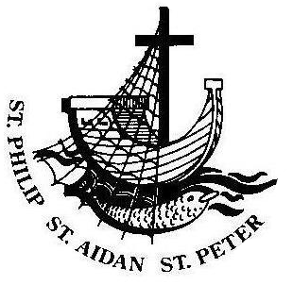
Parish Link

The Vicar writes…

Welcome to our online and in-person worship today! Welcome also to Father Harry Kerr, our guest preacher and celebrant this morning. This is the last time we have the opportunity to hear from Harry as he and Pam prepare to move to be closer to family very soon and we pray God’s blessings be upon them. Next Sunday will be a celebration of Harry’s ministry among us over many years.

My favourite prayer, the one I pray at the beginning of most of my sermons, contains the following line, “We pray for quiet courage to match this hour – we did not choose to be born or to live in such an age…” The readings we hear proclaimed this morning have in my opinion something to say about the nature of time and the time we live in! In the Gospel of Mark we are reminded of the glorious truth that in the coming of Jesus the time is fulfilled and the kingdom is at hand! The apostle Paul in his letter to the Corinthians reminds us that the appointed time has grown short and that the present form of this world is passing away! We live in between the first and the second comings of our Lord and Saviour. It can be a scary and dangerous time; we can grow impatient at the chaos and violence around us and we may even be tempted to give up hope that Jesus will come – but let us also this morning be reminded of the words of the psalmist in psalm 62 – That while “the children of Adam are but breath, the children of earth (are) a lie” we should wait for God: for from him comes our hope. “In God is my deliverance and my glory: God is my strong rock and my shelter.” May our hope never die for it comes from our loving and gracious God.

Mission Statement
Sharing the Good News
Telling the story afresh
Expressing God’s love
Nurturing and sharing faith
Equipping to serve
Serving the community
Vision
To ensure that there continues to be a living, committed, communal Anglican presence of liturgical celebration, nurture and outreach in Box Hill.

FOR YOUR INFORMATION
FIRST AID KIT – Located in the office and kitchen.
TOILETS – Located in the Church Hall and in the church building through the church doors front right.
WHEELCHAIR – Located in the toilet for the disabled upstairs.
FIRE & EMERGENCY – Please make yourself aware of the nearest escape route in the event of an emergency or fire.
OH&S – Please ensure that any incidents/accidents are reported to the Vicar or Wardens and incident report completed.

Sentence
The time is fulfilled, and the kingdom of God is at hand; repent, and believe in the gospel. Mark 1.15
Prayer of the Day
Bountiful God, through your Son you have called us to repent of our sin, to believe the good news, and to celebrate the coming of your kingdom: teach us, like Christ’s first apostles, to hear the call to discipleship, and, forsaking old ways, to proclaim the gospel of new life to a broken world; through our Lord and Saviour Jesus Christ, who lives and reigns with you and the Holy Spirit, one God, now and for ever. Amen

Readings
First Reading: Jonah 3.1-10
¹ The word of the Lord came to Jonah a second time, saying, ² ‘Get up, go to Nineveh, that great city, and proclaim to it the message that I tell you.’ ³ So Jonah set out and went to Nineveh, according to the word of the Lord. Now Nineveh was an exceedingly large city, a three days’ walk across. ⁴ Jonah began to go into the city, going a day’s walk. And he cried out, ‘Forty days more, and Nineveh shall be overthrown!’ ⁵ And the people of Nineveh believed God; they proclaimed a fast, and everyone, great and small, put on sackcloth. ⁶ When the news reached the king of Nineveh, he rose from his throne, removed his robe, covered himself with sackcloth, and sat in ashes. ⁷ Then he had a proclamation made in Nineveh: ‘By the decree of the king and his nobles: No human being or animal, no herd or flock, shall taste anything. They shall not feed, nor shall they drink water. ⁸ Human beings and animals shall be covered with sackcloth, and they shall cry mightily to God. All shall turn from their evil ways and from the violence that is in their hands. ⁹ Who knows? God may relent and change his mind; he may turn from his fierce anger, so that we do not perish.’ ¹⁰ When God saw what they did, how they turned from their evil ways, God changed his mind about the calamity that he had said he would bring upon them; and he did not do it.
For the word of the Lord, thanks be to God
Psalm: 62.5-12
⁵ Nevertheless, my soul, wait in silence for God:
for from him comes my hope.
⁶ He only is my rock and my salvation:
my strong tower, so that I shall not be moved.
⁷ In God is my deliverance and my glory:
God is my strong rock and my shelter.
⁸ Trust in him at all times, O my people:
pour out your hearts before him, for God is our refuge.
⁹ The children of Adam are but breath, the children of earth are a lie:
place them in the scales and they fly upward, they are as light as air.
¹⁰ Put no trust in extortion, do not grow worthless by robbery:
if riches increase, set not your heart upon them.
¹¹ God has spoken once, twice have I heard him say:
that power belongs to God,
¹² That to the Lord belongs a constant goodness:
for you reward each one of us according to our works.

Second Reading: 1 Corinthians 7.29-31
²⁹ I mean, brothers and sisters, the appointed time has grown short; from now on, let even those who have wives be as though they had none, ³⁰ and those who mourn as though they were not mourning, and those who rejoice as though they were not rejoicing, and those who buy as though they had no possessions, ³¹ and those who deal with the world as though they had no dealings with it. For the present form of this world is passing away.
For the word of the Lord, thanks be to God
The Gospel of our Lord Jesus Christ
according to Mark, Chapter 1, verses 14-20
Glory to you Lord Jesus Christ
¹⁴ Now after John was arrested, Jesus came to Galilee, proclaiming the good news of God, ¹⁵ and saying, ‘The time is fulfilled, and the kingdom of God has come near; repent, and believe in the good news.’ ¹⁶ As Jesus passed along the Sea of Galilee, he saw Simon and his brother Andrew casting a net into the lake—for they were fishermen. ¹⁷ And Jesus said to them, ‘Follow me and I will make you fish for people.’ ¹⁸ And immediately they left their nets and followed him. ¹⁹ As he went a little farther, he saw James son of Zebedee and his brother John, who were in their boat mending the nets. ²⁰ Immediately he called them; and they left their father Zebedee in the boat with the hired men, and followed him.
For the Gospel of our Lord, praise to you Lord Jesus Christ

Years Mind
Bertram de Zilwa, Helen Burkett, Clive Jackson and Daisy Stanley, whose anniversaries occur at this time.
Prayer Points
The Church: Pray for The Church of Bangladesh; The Diocese of Adelaide (Abp Geoff Smith, Asst Bps Denise Ferguson, Timothy Harris, Christopher McLeod; Clergy & People); Aged Care Ministry; City on a Hill Melbourne (Guy Mason, Andrew Grills, Matt Keller, Stephanie Judd, Andrew Pearce, Luke Nelson); St George's Anglican Church Red Hill – Pastoral Service (Bishop Paul Barker)
The Parish: Give thanks for the work of the Sudanese Saturday School as they prepare for a new year.
The World: Pray for countries affected by cyclones, earthquakes and other natural disasters.
The Nation: Pray for teachers and students as they prepare to start a new year.
Prayer of the Week
O God, the strength of all those who put their trust in you: mercifully accept our prayers, and because through the weakness of our mortal nature we can do nothing good without you, grant us the help of your grace, that in keeping your commandments we may please you both in will and deed; through Jesus Christ our Lord. Amen.

Daily Readings
Monday | Hebrews 9.15, 24-28 | Ps 98.1-7 | Mark 3.22-30
Tuesday | Hebrews 10.1-10 | Ps 40.6-10 | Mark 3.31-35
Wednesday | Hebrews 10.11-18 | Ps 110.1-4 | Mark 4.1-20
Thursday | Hebrews 10.19-25 | Ps 24.1-6 | Mark 4.21-25
Friday | Hebrews 10.32-39 | Ps 37.35-41 | Mark 4.26-34
Saturday | Hebrews 11.1-2, 8-19 | Song of Zechariah 1-6 | Mark 4.35-41

If you have anything you would like included in
the Parish Link Notices, please let Cecilia know in writing before Thursday 9899 5122 or anglicans.boxhill@bigpond.com

CHILD SAFETY REGULATIONS
In line with the regulations set out by the diocese, our Child Safety Policy requires that those whose work involves children in any way must obtain a Working With Children Check as well as a CrimCheck. We are in the process of ensuring that everyone in our parish has the required checks and are sending emails to those people to let them know.
It is also a requirement that those in responsible positions have CrimChecks, including all Parish Council members.
Please assist us by attending to these checks as soon as possible. Cecilia in the office can assist you with any queries.

The World Day of Prayer 2021 host country is Vanuatu and the theme is “Build on a Strong Foundation”.
This year’s service has been prepared by the women of Vanuatu. It would be great to have some of our congregation present on the day.
Place: St Andrew’s Uniting Church, 909 Whitehorse Road, Box Hill (opposite tram terminal)
Date: Friday, March 5, 2021
Time: 2.00pm

SAMARITAN’S PURSE
Back to school products are now available and items I have bought from Big W and Office Works have been great value. Buy now at reasonable prices to get a head start on your boxes. My starter bags will be available at any time as well.
Jan Gunst, Samaritan’s Purse Co-ordinator.

Congratulations
to Fred Tooth who reaches
this milestone on Thursday
of this week!

FAREWELL TO FATHER hARRY
Next Sunday, January 31, will be the last Sunday Father Harry will be in the parish and there will be a morning tea for him in the hall after the service. If you can contribute food for this, please speak to Barbara Plumridge or Michele Mitchell. This will be an opportunity for us to thank him for his work while he has been here and wish him well for the future.

To make you smile…
A Catholic priest, a Rabbi and an Imam were meeting together at an interfaith council when they were interrupted by a secretary who rushed in exclaiming, "God's on the phone for you, Fr. Murphy." Fr. Murphy listens a moment, nods gravely and then hangs up. He turns to the Rabbi and the Imam and says, "I have good news and bad news. The good news is that God loves us. The bad news is he's calling from Salt Lake City."

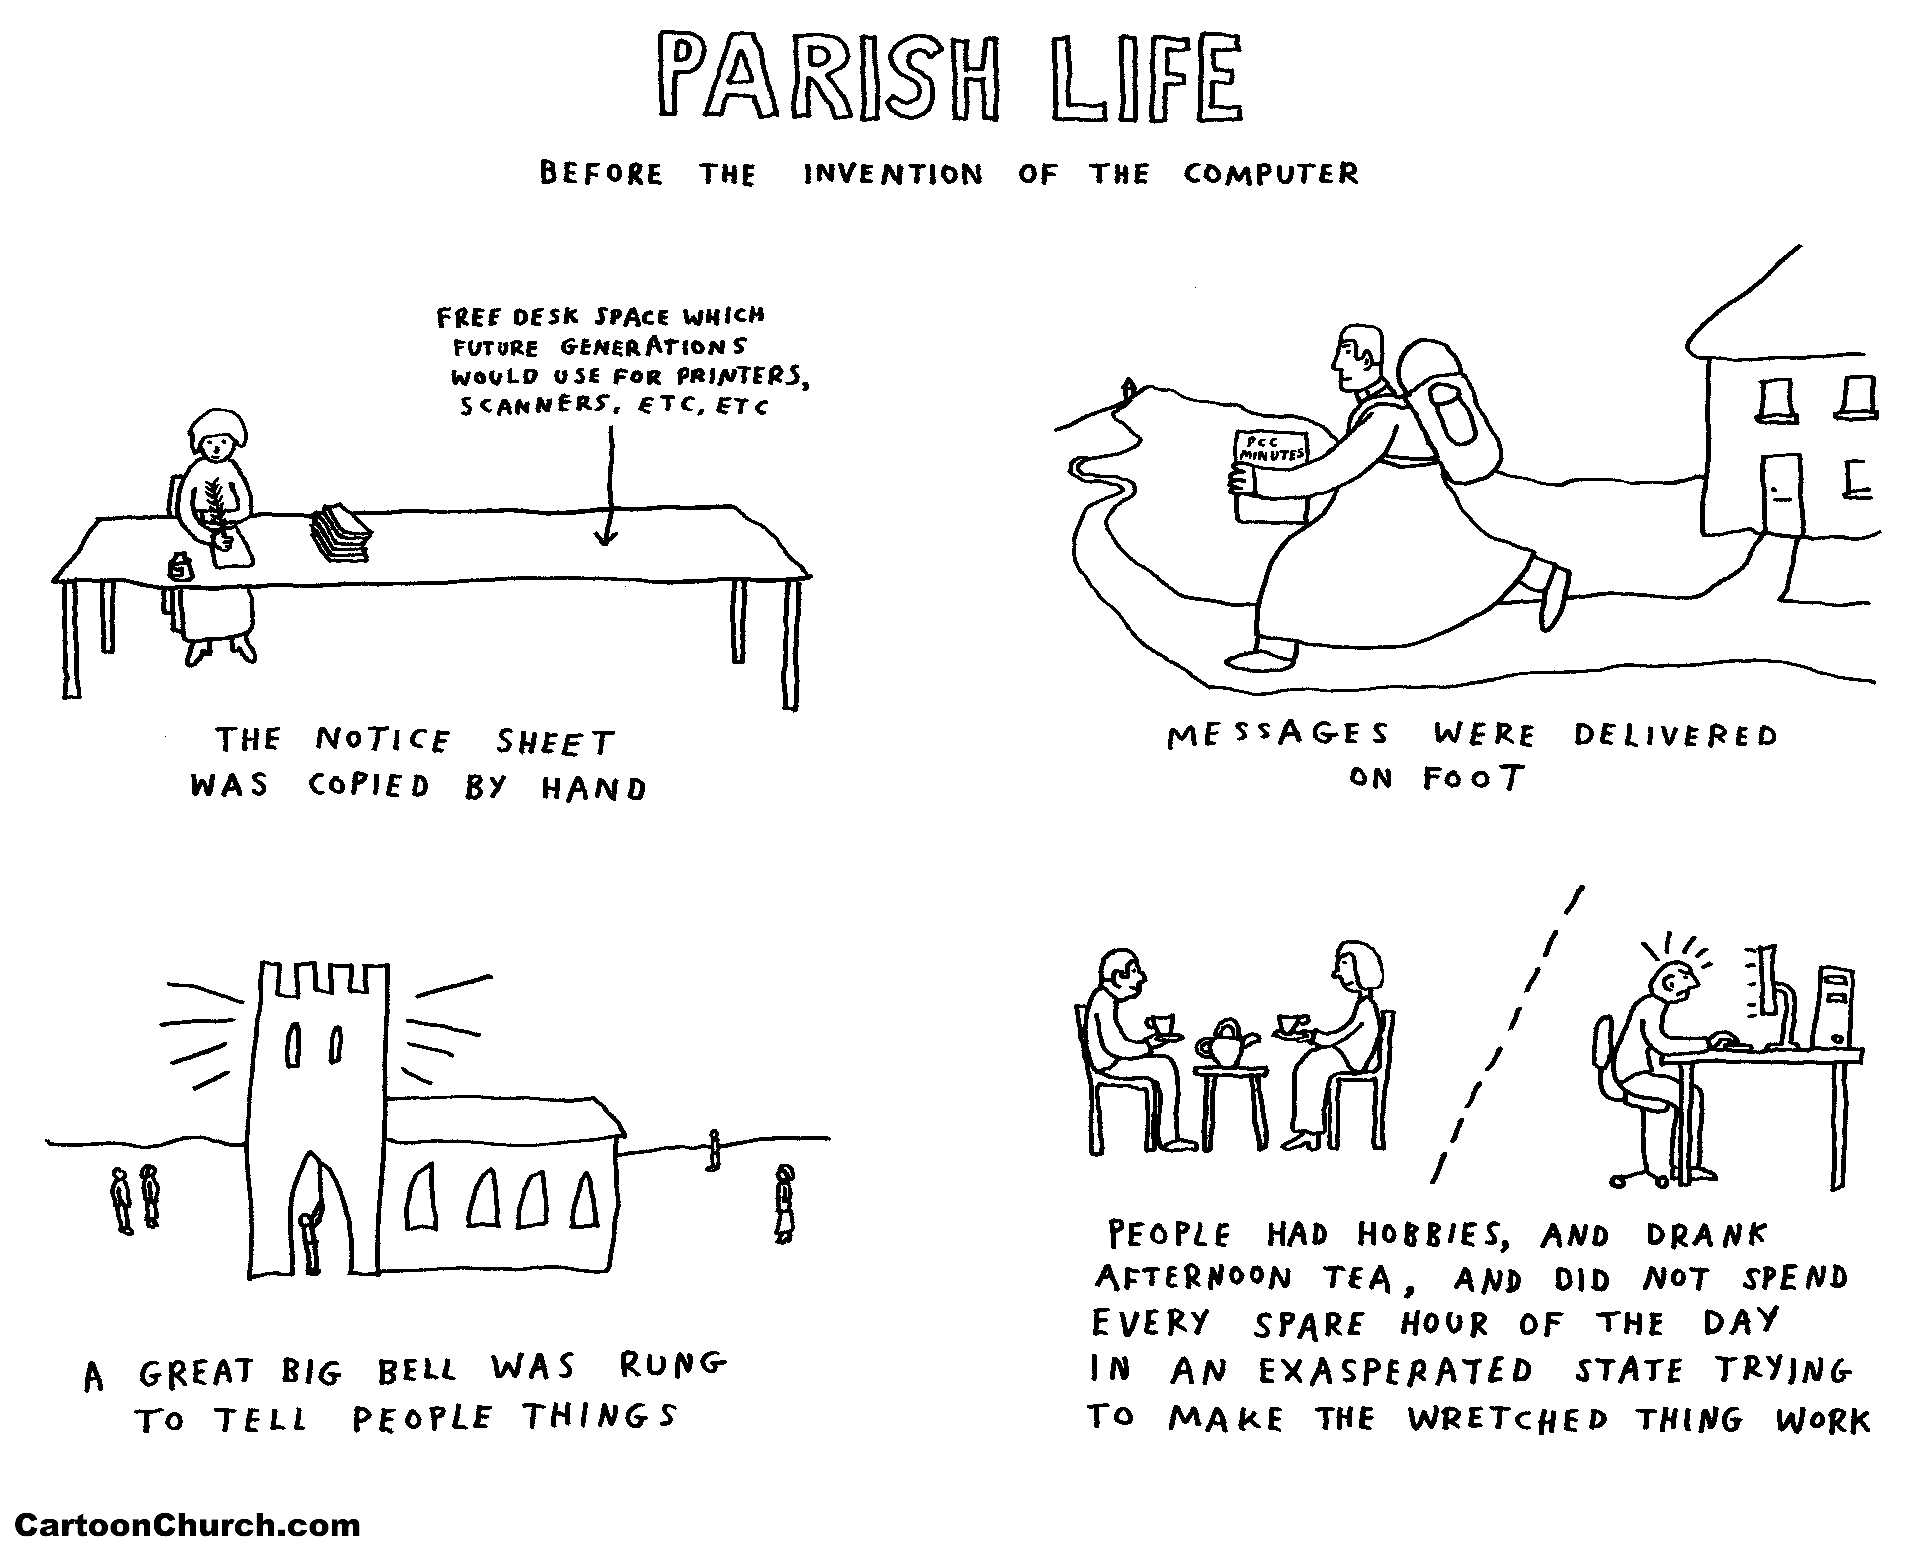

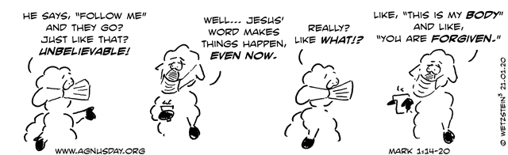

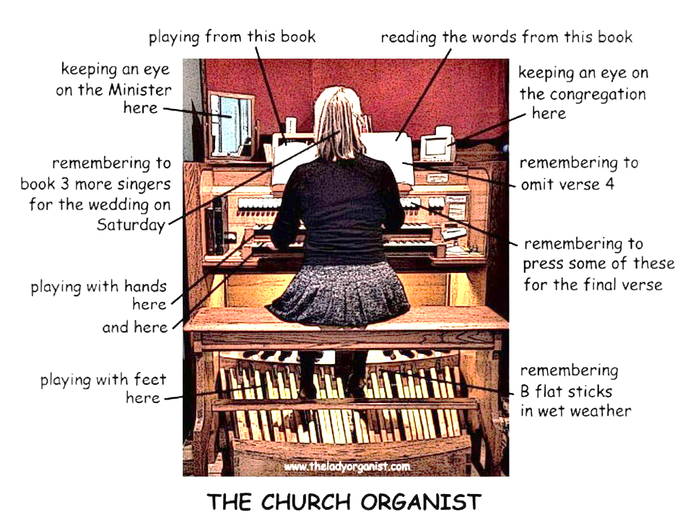
This Week
Vicar
The Reverend Shane Hübner
T 0432 681 177
E vicar@anglicansboxhill.org.au
Honorary Clergy
The Rt Rev George Hearn,
T 9840 7816
Reverends:
Betty Bracken 9939 5881
Harry Kerr 9893 4946
Alasdair MacKinnon-Love 0438 323 059
E alasdair@mackinnonlove.com
Sudanese Ministry
Reverend Joseph Arou
T 0431 541 535
E lokagai@hotmail.com
Chinese Ministry
The Reverend Esther Zhang
T 0405 602 439
Family Minister
Barbara Plumridge
T 0405 193 122
E barbara.plumridge@gmail.com

SUN 24.1.21
Third Sunday after Epiphany
8.00am, 9.30am Eucharist
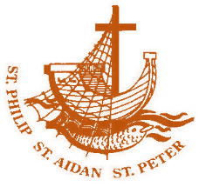
11.30am Mandarin service
2.30pm Dinka service

MON 25.1.21

TUES 22.12.21
8.00-11.00am Men at Work
8.30am – 12.30pm Office open
WED 23.12.21
10.30am Eucharist
THU 24.12.21
10am – 2pm Office open

FRI 25.1.21
7.30am Eucharist
SAT 26.1.21

SUN 27.1.21
Fourth Sunday after Epiphany
8.00am, 9.30am Eucharist
Fr Harry’s Farewell
11.30am Mandarin service
2.30pm Dinka service

Wardens:
Margaret Dooley 0438 129 161
Sophia Errey 9878 6297
Garry Plumridge 9898 5193

Reporting Child Abuse
All child safety concerns must be reported.
Kooyoora Professional Standards 1800 135 246
ST PETER’S
1038 Whitehorse Rd, Box Hill.
Parish Office: 9899 5122
Email
anglicans.boxhill@bigpond.com
Website www.anglicansboxhill.org.au
Office Hours:
Tues 8.30am – 12.30pm
Thu 10.00am – 2.00pm

Wardens:
Margaret Dooley 0438 129 161
Sophia Errey 9878 6297
Garry Plumridge 9898 5193

