St Benedict and the place of personal prayer
08 FEBRUARY 2021
27

St Benedict’s instructions for prayer give voice to the whole Church, but not at the expense of the individual, says Luigi Gioia

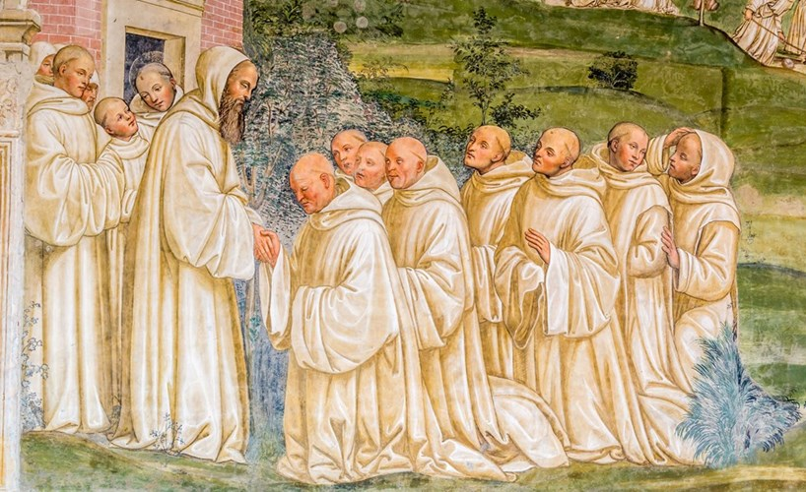ALAMY
A fresco of St Benedict from the cloisters of the Abbey of Monte Oliveto Maggiore, in Tuscany
THE first image that comes to our minds when we think of monastic life is nuns and monks wearing wide-sleeved, hooded cowls, either processing or standing, bowing, and chanting in their assigned stalls in richly decorated choirs.
They gather to pray together up to seven times a day, starting before dawn with matins and ending with compline just before going to bed. Every day, they devote three to five hours to this activity, which is called opus Dei, “the work of God”; or the “Office”, by singing psalms, reading scripture, celebrating the Eucharist.
Times of silence follow the readings, but usually are very short — a way of catching one’s breath before moving on to the next psalm. Each detail in this activity is codified, and there is very little place left for spontaneity or the expression of the individual’s feelings or needs.
Monastics might have to sing a joyful psalm even if in that moment they are upset, or a psalm of distress even when they feel perfectly at peace. They know that during the liturgy they are expressing the feelings of the whole Church, giving voice to Sisters and Brothers who are suffering or in need in the other parts of the globe.
The Rule of St Benedict (RB) devotes some 19 chapters to the meticulous description of the way in which the Office should be celebrated: timing, content, posture, delays, negligence, and even exceptions, such as praying the Office in places located far from the chapel or while traveling (RB 50 and 51).
Common liturgical prayer is at the heart of the spiritual life of the community and of each nun and monk — a principle enshrined in one of the crucial sentences of the Rule: “Nothing is to be preferred to the Work of God” (RB 43.3).

IN CONTRAST, St Benedict speaks very little about personal prayer, and only incidentally. It would be tempting to attribute such brevity to a devaluation of personal prayer as compared with liturgical prayer.
Benedictine spirituality has always flirted with formalism, as if spiritual life depended on the number of psalms sung during a given day, on the quality of the singing, on perfect timing, on the beauty of the celebration, and the splendour of vestments.
Therefore, monastics, too, need to be reminded that Christianity is first of all about cultivating a personal relation of trust and love with God, as Jesus makes clear when he warns that we should avoid imitating “the hypocrites who love to pray standing in the synagogues and on the street corners to be seen by others”, and the “pagans who think they will be heard because of their many words”, and instead invites us to pray to God our Father “in the secret” of our hearts (cf. Matthew 6.5-8).
Interestingly, Jesus’s “secret” is suggested in Benedict’s acknowledgement that there are times in which monastics might want to pray by themselves (peculiariter, RB 52.3) or in private (secretius, RB 52.4).
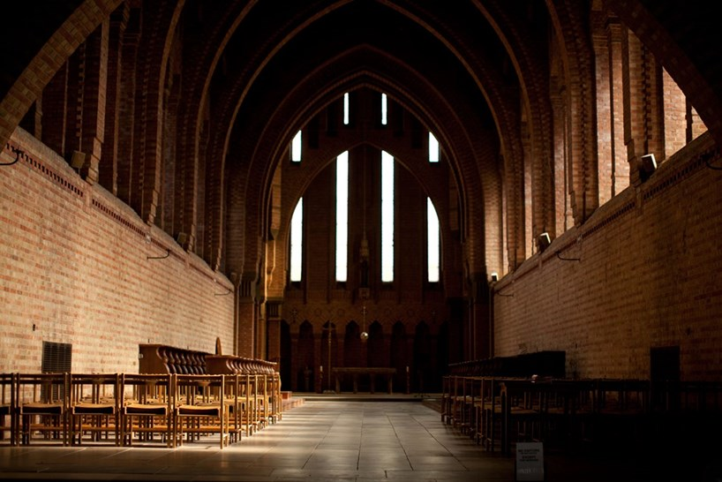ALAMY
“Nothing else is to be done or stored there”: the oratory at Quarr Benedictine Abbey, near Ryde, Isle of Wight

Just as with his hesitation with regards to the quantity of food or drink that should be distributed to each nun or monk (RB 39 and 40), the concision of Benedict’s thoughts on prayer has an obvious explanation: prayer depends on individual dispositions, and therefore cannot be imposed through external regulations.
All that a Rule should do about personal prayer is create the conditions that protect its freedom and its spontaneity.
At the same time, despite their brevity, the passages of the Rule that talk about prayer brim with terse and yet evocative insights on what makes it truly genuine.
These remarks tend to be all the more striking as they occur almost inadvertently, as for example in chapter 52, “The Oratory of the Monastery”, which deals with the place where monks should gather for their liturgical prayer:
“The oratory ought to be what it is called, and nothing else is to be done or stored there. After the Work of God, all should leave in complete silence and with reverence for God, so that a brother who may wish to pray alone will not be disturbed by the insensitivity of another.
“Moreover, if at other times someone chooses to pray privately, he may simply go in and pray, not in a loud voice, but with tears and heartfelt devotion. Accordingly, anyone who does not pray in this manner is not to remain in the oratory after the Work of God, as we have said; then he will not interfere with anyone else.” (RB 52)

IN THE monastery there should be a hall especially set apart for prayer. We should not forget that Benedict was writing for sixth-century monastics before clear architectural conventions about the structure of a monastery had been established.
Just as today most churches are not just places for liturgical celebrations but often host social or cultural events, so ancient monastics might have been tempted to use part of their chapel for storage or as a meeting place. The interest of this chapter, however, lies in the explanation Benedict gives for this norm.
He is not concerned about the misuse of a sacred space, but wants to make sure that there is a place where Sisters and Brothers can pray privately at any time of the day. Here, however, he drops an unexpected sentence that captures the essence of his idea of personal prayer: if someone “chooses to pray privately, he may simply go in and pray” (simpliciter intret et oret).
The obvious meaning of this sentence is that the Sister or the Brother should feel free to enter the chapel directly, naturally, discreetly, and spontaneously. This betrays Benedict’s conviction that personal prayer cannot be ritualised or codified in the same way as liturgical prayer, and should be left to everyone’s initiative.
In Latin, however, the same adverb (simpliciter) can also have the ethical meaning of “sincerely, candidly, genuinely”. Benedict uses it with this meaning when he says that, if a monastic visiting from another community is “simply [simpliciter] content with what he finds, he should be received for as long a time as he wishes” (RB 61.3).
In this case, the sentence quoted above can be interpreted as indicating the qualities of authentic prayer: if someone desires to pray alone in private, let him enter and pray sincerely, candidly, genuinely. We should therefore look for clues that explain what Benedict means by a sincere, candid, genuine, simple personal prayer.
The adverb simpliciter resonates with the etymology of the word “monk”, which comes from the Greek monos, “alone, only, single”. A common mistake is to interpret this word as implying that a monk should lead a solitary or eremitical life. In fact, monastics started to be designated with this word not because of their “single life”, but, rather, owing to their “single-mindedness”; that is, their choice of a lifestyle focused on the only necessary thing according to Jesus’s words to Martha: “You are anxious and worried about many things. There is need of only one thing” (Luke 10.41-42) — namely, sitting at his feet and listening to him.
Monos, therefore, refers to a lifestyle unified around the purpose of seeking God: the simplification of life is meant to facilitate the unification of the heart. Monastics yearn to acquire a heart undivided — that is, united to the Lord, according to a sentence from the Psalms: “Give me an undivided heart to revere your name” (Psalm 85.11, NRSV). What unifies the monastics’ life is the gentle, obstinate, lifelong desire to overcome idolatry by clinging to the Lord with all their heart, all their soul, and all their strength (cf. Matthew 22.37).
For the prophet Jeremiah, this is the core of the covenant: “They shall be my people, and I will be their God. I will give them one heart and one way, that they may fear me always, for their own good and the good of their children after them” (Jeremiah 32.38-39) — and Paul promises that “whoever is joined to the Lord becomes one spirit with him” (1 Corinthians 6.17).
This is an edited extract from The Wisdom of St Benedict: Monastic spirituality and the life of the Church by Luigi Gioia OSB, published by Canterbury Press at £16.99 (Church Times Bookshop £14.99); 978-1-78622-309-8.
Luigi Gioia is one of the speakers at the Church Times Festival of Preaching, taking place on Tuesday 9 February.

