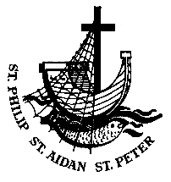
ANGLICAN PARISH OF BOX HILL
3 July 2022
Patronal Festival
Parish Link

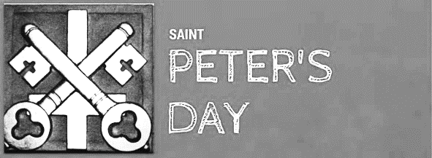
The Vicar writes…
Welcome to our Patronal festival as we celebrate our Patron Saint – St Peter. First of all, thank you to Father Alasdair for looking after the parish while I have been on long service leave, and second, welcome to Bishop Alison Taylor, who is guest preacher today for our special celebration!
Of all the episodes involving Peter in the Gospel one of my favourites is his response to Jesus’ question, “Who do you say that I am?” Peter says, “You are the Christ, the Son of the living God.” Last week I had the great honour to be at the place where this occurs in the New Testament: Caesarea Philippi, about 25k north of the Sea of Galilee. There could have been few districts with more religious associations than Caesarea Philippi. The Syrians had many temples there; the area was said to be the birthplace of the Greek God Pan; the River Jordan was said to start here and Herod the Great had built a great temple of white marble to the godhead of Caesar. It was Herod’s son Philip who changed the name of the place from Panias to Caesarea and added his own name Philippi - of Philip to distinguish it from Caesarea on the Mediterranean. It is not hard to see Jesus standing amidst the religions and idols and temptations of our day, saying the same question to us, “Who do you say that I am?” Can we answer like our patron Peter that Jesus is the Christ, the Son of the living God?
Can we be the rocks upon which Christ builds his church? The Church of God is more than these lovely buildings that we come to once a week. The church is you and me - the relationships we have with each other in the body of Christ. And that’s why to know God involves more than just knowing about him. Theology is good and right and if we do not exercise our minds to the fullest concerning the nature of God and our relationship with him, then we pay God a disservice; however, the key is in our worship of the living God; in our relationship with God that goes on every day. We can rest in God but we cannot rest in the armchair watching others grow and go on. Our prayer is that we can answer Jesus’ question “Who do you say that I am?” with the answer “You are to me the Christ - the son of the living God and I will praise, reverence, and serve you, for that is why I am created”.

Welcome  欢迎  Wek Cuke Loor  خوش آمدید
Sentence: Peter says to Jesus, ‘Lord, you know everything; you know that I love you.’ John 21.17
Prayer of the Day
Almighty God, whose apostles Peter and Paul glorified you in their deaths as in their lives: grant that your Church, inspired by their teaching and example, and knit together in unity by your Spirit, may ever stand firm upon the one foundation, your Son Jesus Christ our Lord; who lives and reigns with you, in the unity of the Holy Spirit, one God, now and for ever. Amen.

First Reading: Acts 12.1-11
¹ About that time King Herod laid violent hands upon some who belonged to the church. ² He had James, the brother of John, killed with the sword. ³ After he saw that it pleased the Jews, he proceeded to arrest Peter also. (This was during the festival of Unleavened Bread.) ⁴ When he had seized him, he put him in prison and handed him over to four squads of soldiers to guard him, intending to bring him out to the people after the Passover. ⁵ While Peter was kept in prison, the church prayed fervently to God for him. ⁶ The very night before Herod was going to bring him out, Peter, bound with two chains, was sleeping between two soldiers, while guards in front of the door were keeping watch over the prison. ⁷ Suddenly an angel of the Lord appeared and a light shone in the cell. He tapped Peter on the side and woke him, saying, ‘Get up quickly.’ And the chains fell off his wrists. ⁸ The angel said to him, ‘Fasten your belt and put on your sandals.’ He did so. Then he said to him, ‘Wrap your cloak around you and follow me.’ ⁹ Peter went out and followed him; he did not realize that what was happening with the angel’s help was real; he thought he was seeing a vision. ¹⁰ After they had passed the first and the second guard, they came before the iron gate leading into the city. It opened for them of its own accord, and they went outside and walked along a lane, when suddenly the angel left him. ¹¹ Then Peter came to himself and said, ‘Now I am sure that the Lord has sent his angel and rescued me from the hands of Herod and from all that the Jewish people were expecting.’
For the word of the Lord, thanks be to God
Psalm: 34.1-10
I will bless the Lord continually: his praise shall be always in my mouth.
Let my soul boast of the Lord: the humble shall hear it and rejoice.
O praise the Lord with me: let us exalt his name together.
For I sought the Lord’s help and he answered:
and he freed me from all my fears.
Look towards him and be bright with joy: your faces shall not be ashamed.
Here is a wretch who cried, and the Lord heard him:
and saved him from all his troubles.
The angel of the Lord encamps round those who fear him:
and delivers them in their need.
O taste and see that the Lord is good: happy the man who hides in him!
Fear the Lord, all you his holy ones: for those who fear him never lack.
Lions may suffer want and go hungry:
but those who seek the Lord lack nothing good

Second Reading: 2 Timothy 4.6-8 and 17-18
⁶ As for me, I am already being poured out as a libation, and the time of my departure has come. ⁷ I have fought the good fight, I have finished the race, I have kept the faith. ⁸ From now on there is reserved for me the crown of righteousness, which the Lord, the righteous judge, will give to me on that day, and not only to me but also to all who have longed for his appearing. ¹⁷ But the Lord stood by me and gave me strength, so that through me the message might be fully proclaimed and all the Gentiles might hear it. So I was rescued from the lion’s mouth. ¹⁸ The Lord will rescue me from every evil attack and save me for his heavenly kingdom. To him be the glory for ever and ever. Amen.
For the word of the Lord, thanks be to God
The Gospel of our Lord Jesus Christ
according to John, Chapter 21, beginning at Verse 15
Glory to you Lord Jesus Christ
¹⁵ When they had finished breakfast, Jesus said to Simon Peter, ‘Simon son of John, do you love me more than these?’ He said to him, ‘Yes, Lord; you know that I love you.’ Jesus said to him, ‘Feed my lambs.’ ¹⁶ A second time he said to him, ‘Simon son of John, do you love me?’ He said to him, ‘Yes, Lord; you know that I love you.’ Jesus said to him, ‘Tend my sheep.’ ¹⁷ He said to him the third time, ‘Simon son of John, do you love me?’ Peter felt hurt because he said to him the third time, ‘Do you love me?’ And he said to him, ‘Lord, you know everything; you know that I love you.’ Jesus said to him, ‘Feed my sheep. ¹⁸ Very truly, I tell you, when you were younger, you used to fasten your own belt and to go wherever you wished. But when you grow old, you will stretch out your hands, and someone else will fasten a belt around you and take you where you do not wish to go.’ ¹⁹ (He said this to indicate the kind of death by which he would glorify God.) After this he said to him, ‘Follow me.’ ²⁰ Peter turned and saw the disciple whom Jesus loved following them; he was the one who had reclined next to Jesus at the supper and had said, ‘Lord, who is it that is going to betray you?’ ²¹ When Peter saw him, he said to Jesus, ‘Lord, what about him?’ ²² Jesus said to him, ‘If it is my will that he remain until I come, what is that to you? Follow me!’
For the Gospel of our Lord, praise to you Lord Jesus Christ
Prayer of the Week
O God, who for our redemption gave your only-begotten Son to suffer death upon a cross, and by his glorious resurrection delivered us from the power of the enemy:
grant us so to die daily to sin that we may evermore live with him in the joy of his resurrection; through the same Jesus Christ our Lord. Amen.
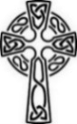
Years Mind
Dorothy Lapworth, Fr James Robertson Senior, Peter Danby, Fr Kevin Joyner, Evelyn Carty-Salmon, Mark Borg, Harold Shepherd, and Mary Carden, whose anniversaries occur at this time.
Prayer Points
The Church: The Anglican Church of Tanzania (Abp. Maimbo William Mndolwa); The Diocese of Melbourne (Abp Philip Freier, Asst Bps Paul Barker, Bradly Billings, Genieve Blackwell, Kate Prowd, Clergy & People); Ecumenical Affairs Committee; St Thomas' Werribee (vacant incumbency, Nisher Kunoo).
The Parish: Give thanks for our Patronal Festival and for the return of Fr Shane.
The World: Pray for the people of Afghanistan and all affected by earthquakes.
The Nation: Pray for all unemployed and those unhappy at work.
Daily Readings
Monday | Hosea 2.16-22 | Ps 145.1-9 | Matthew 9.18-26
Tuesday | Hosea 8.4-7, 11-13 | Ps 115.1-11 | Matthew 9.32-38
Wednesday | Hosea 101-12 | Ps 105.1-7 | Matthew 10.1-7
Thursday | Hosea 11.1-9 | Ps 80.1-2, 14-19 | Matthew 10.7-15
Friday | Hosea 14.2-10 | Ps 51.6-15 | Matthew 10.16-23
Saturday | Isaiah 6.1-8 | Ps 93 | Matthew 10.24-33

If you have anything you would like included in the Parish Link Notices, please let Cecilia know in writing before Thursday at anglicans.boxhill@bigpond.com

GREEN TIP OF THE WEEK
About 4.7 billion plastic toothbrushes wash up on the world’s shores every year so it is worth finding an alternative. Bamboo-handled toothbrushes are an improvement.
MOTHERS’ UNION
Eight visitors and 11 members enjoyed an afternoon of fellowship, viewing clothing and afternoon tea while attending the Blume’s Fashions event. We may see a few fashions at church! Five small raffle prizes raised $95 which will be forwarded to MU office and put towards the Australian Disaster Fund which has been in demand with floods and fires.
The next meeting is Wednesday, 27 July. We will take part in the worldwide Wave of Prayer.

FOOD DONATIONS
All food donations for those in need are much appreciated and delivered regularly (thank you Margaret P, Laurence and Jan!). We are trialling a new system where food bags can be dropped off in the Undercroft and will be kept there until collected. This means you can drop them off on your way in via the Undercroft or after the service at morning teatime. If you have a problem with this, see Cecilia who can take them in for you.

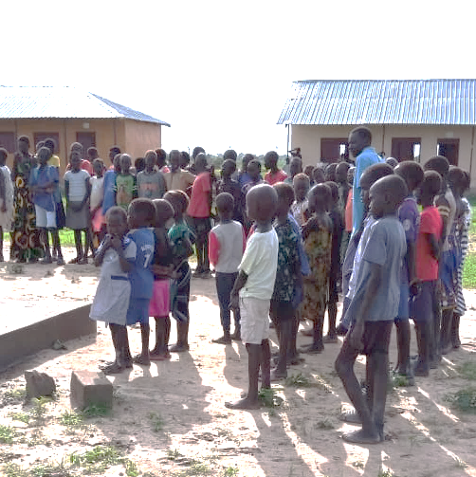
BOR ORPHANAGE AND SCHOOL – UPDATE
Our school is operational and fully staffed. Fr Joseph was involved in the selection of teaching and support staff while he was in Bortown. Many schools in South Sudan have difficulty finding the money to pay teachers, so teachers leave to earn money elsewhere. To keep our staff, we have committed to paying the staff on time each month. Many of the families struggle to pay school fees, so we ask for your continued support to help meet the costs of paying teachers and running the school.
A reminder to all our supporters that our charity is registered with the Australian Charities & Not-for-profit Commission (ACNC) as a public benevolent institution, and all donations of $2 or more are tax-deductible. In early July I will issue tax receipts to all who have made a donation to our building appeal in the 2021-2022 tax year.
Donations can be made to our bank account in Box Hill:
Bank: ANZ BSB: 013 225
Account: 280731691
Account name: ABAAR ORPHANAGE BORTOWN SOUTH SUDAN INC Margaret Dooley

FREE PUBLIC LECTURE
Join us for the Hughes-Cheong public lecture, to be presented by our visiting scholar Dr Willie James Jennings, Associate Professor of Systematic Theology and Africana Studies, Yale Divinity School, Yale University.
Thursday 7 July 2022, 7.30–9pm Craig Auditorium, Gateway Building, Trinity College, 100 Royal Parade, Parkville (enter via Gate C)
RSVP by 5pm Wednesday 6 July 2022 Click here to RSVP
Enquiries: Trinity College Theological School | 03 9348 7127
theologyevents@trinity.edu.au
THANK YOU TO mICHELE
A very big thank you to Michele for taking on the gigantic task of producing a master roster and for doing it so well! We all need to be aware of possible clashes and when we may not be able to do our task and make sure that we find others to fill in when necessary. Thank you all as well for being supportive.

TO make you smile…
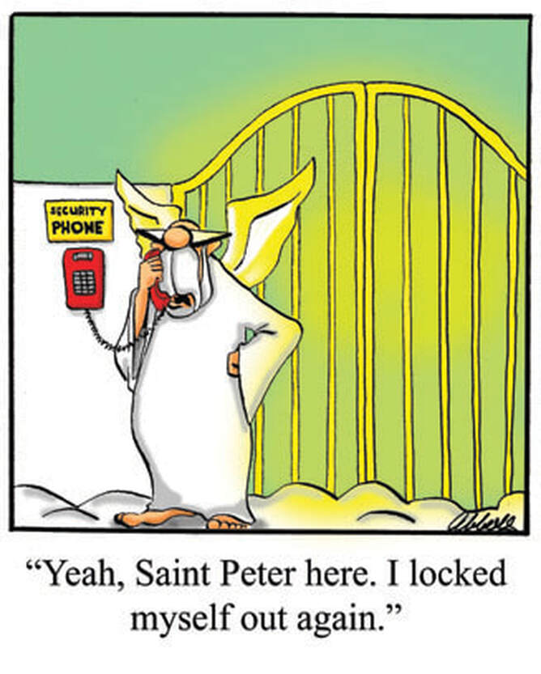
Saint Peter went running up to God expressing concern that a large group of Russians are waiting outside the pearly gates.
‘Tell them to line up and think about their sins’ shouts the Almighty One.
A short while later St Peter returns shouting 'They've gone'
God cries 'What all 150,000 of them?'
St Peter replies 'No, the gates. They've taken the gates!'
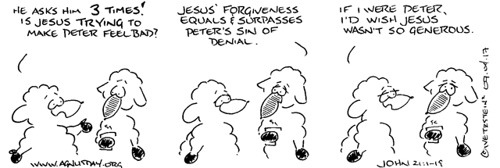
Week Ahead
For the Diary
July 9
Piano set up and concert 4.30-8.30pm

July 16
Brahms Piano concert 6.00pm
(set up 5.00pm)
Fundraiser for East Gippsland community

July 17
Conrad Hamann speaks on
Historic Churches in the Box Hill Area
2.00pm Box Hill Library

July 23
Piano set up and concert 1.30-4.30pm

July 27
Mothers’ Union Meeting
SUNDAY 3.07.22
St Peter’s Day
11.30am Patronal Festival
2.30-4.30pm Prayers in Mandarin, St Aidan’s
5.00am Farsi Service, St Aidan’s

MON 4.07.22
9.30-10.30am Tai Chi hall (on holiday)
6.30-8.30pm Tai Chi hall (on holiday)

TUES 5.07.22
8.30am-12.30pm Office open
9.00-1.00pm Men at Work
6.00-8.00pm Bellydancing, hall

WED 6.07.22
10.30am Eucharist
9.30-11.30am Play group (kindergarten)
Prayers and Readings from A Prayer Book for Australia, Copyright Broughton Publishing 1995.
The Scripture quotations contained herein are from the New Revised Standard Version of the Bible © 1989 the Division of Christian Education of the National Council of the Churches of Christ in the United States of America, and are used by permission. All rights reserved.

Starting Term 3
10-11.30am Tai Chi hall (on holiday)
8.00-900pm Choir practice, Undercroft

THU 7.07.22
9.00am-1.00pm Office open
6.30-9.30pm Crossways ESL, hall
(on holiday)

FRI 8.07.22
7.30am Eucharist
OUR INFORMATION
FIRST AID KIT – Located in the office and kitchen.
TOILETS – Located in the Church Hall and in the church building through the church doors front right.
WHEELCHAIR – Located near the toilet for the disabled upstairs.
FIRE & EMERGENCY – Please make yourself aware of the nearest escape route in the event of an emergency or fire.
OH&S – Please ensure that any incidents/accidents are reported to the Vicar or Wardens and incident report completed.
5.30-9.30pm Mandarin Prayer Group

SAT 9.07.21
10.30am-1.30pm Saturday School, hall and
Undercroft (on holiday)
4.30-8.30pm Piano set up and concert

SUNDAY 10.07.22
8.00am Eucharist, 9.30am Eucharist
11.30am Mandarin service
2.30pm Dinka service
2.30-4.30pm Prayers in Mandarin, St Aidan’s
5.00pm Farsi Service, St Aidan’s

4th Sunday of the month: retiring collection for parish outreach

m
ST PETER’S
1038 Whitehorse Rd, Box Hill.
Parish Office: 9899 5122
Eanglicans.boxhill@bigpond.com
W www.anglicansboxhill.org.au

Office Hours:
Tues 8.30am – 12.30pm
Thu 9.00am – 1.00pm

Vicar
The Reverend Shane Hübner
T 0432 681 177
E vicar@anglicansboxhill.org.au
Honorary Clergy
The Rt Rev George Hearn
Reverends:
Betty Bracken 9939 5881
Anne Kennedy E robann29@bigpond.com
Alasdair MacKinnon-Love 0438 323 059
E alasdair@mackinnonlove.com
Chinese Ministry
The Reverend Esther Zhang
T 0405 602 439 E esther_win@hotmail.com
Sudanese Ministry
Reverend Joseph Arou
T 0431 541 535
E aroujoseph18@gmail.com

Wardens:
Margaret Dooley 0438 129 161
Sophia Errey 9878 6297
Garry Male 0421 056 706

Mission Statement
Sharing the Good News
Telling the story afresh
Expressing God’s love
Serving the community
Nurturing and sharing faith
Equipping to serve
Vision
To ensure that there continues to be a living, committed,
communal Anglican presence of liturgical celebration, nurture and outreach in Box Hill.

Reporting Child Abuse
All child safety concerns must be reported to
Kooyoora Professional Standards 1800 135 246

 | Today 3.7.22 11.30am  Patronal Festival | Next week 10.7.22
SIDESPEOPLE | Sandra L, Noel W | Michele M, Barbara P
SERVERS | Rosemary S, Michele M, Garry M | Elizabeth B, Judy J, Kim C
READERS | TBA | Martin F, Edwin C
INTERCESSOR | Vicar | Michele M
COUNTING | Hilary B, Elizabeth B | Michele M, Rob K
MORNING TEA | All available helpers who can assist. Setting up from 10am. | Rosemary S, Peter W, Janet H
Roster for 11.30am Patronal Festival and 9.30am services.
St Peter’s is part of the Anglican Church of Australia and the worldwide Anglican Communion.
St Peter’s church is on the land of the Wurundjeri people of the Kulin nation and we acknowledge them as the traditional custodians of this land.

